**Assignment 0**

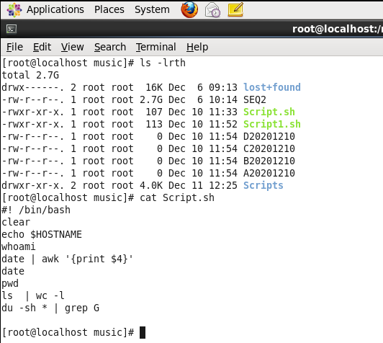

Output

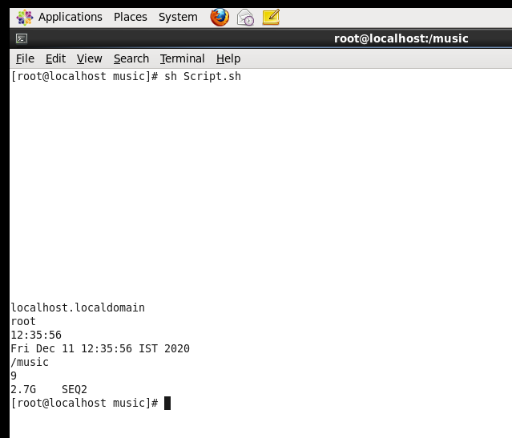

**Assignment 1**

Created files

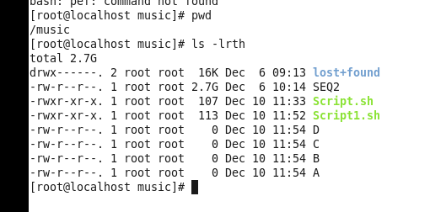

Scrip1.sh

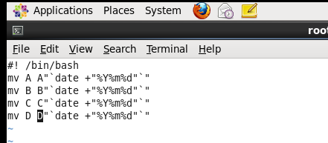

Output After Script

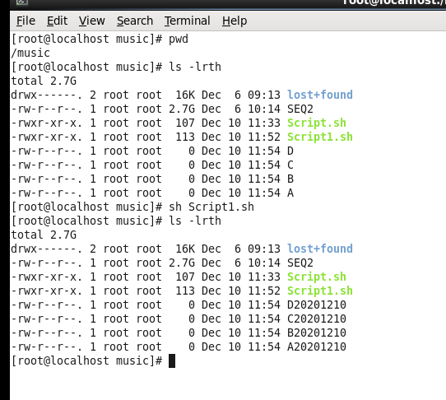

**Assignment 2**

Write a script that takes a number as an input and reverses it out to the user. For example, if the original number is 74985, the output should be 58947.

